**Azure data bricks Assessment 2 :** - Abhiram Basa

Today we gone through some intro and created the clusters and did hands on practice for pyspark programs using Azure data bricks.

**Azure Data bricks workspace Objects:**

**Cluster** : It consists of dirvers and workers

Drivers are the ones which assigns work.

Worker are the ones who completes the works.

It has two categories

1. **Single node:** It has one driver and one worker.
2. **Multi node:** It has one driver and multiple workers.

**Notebooks**: It used to run codes in azure databricks.

It has set of commands we can create and run just like jupyter notebook or py notebook

**Jobs:** These are also used to run codes in azure databricks. You can run codes using jobs or notebooks.

* First we created azure data bricks services and click on go to resource

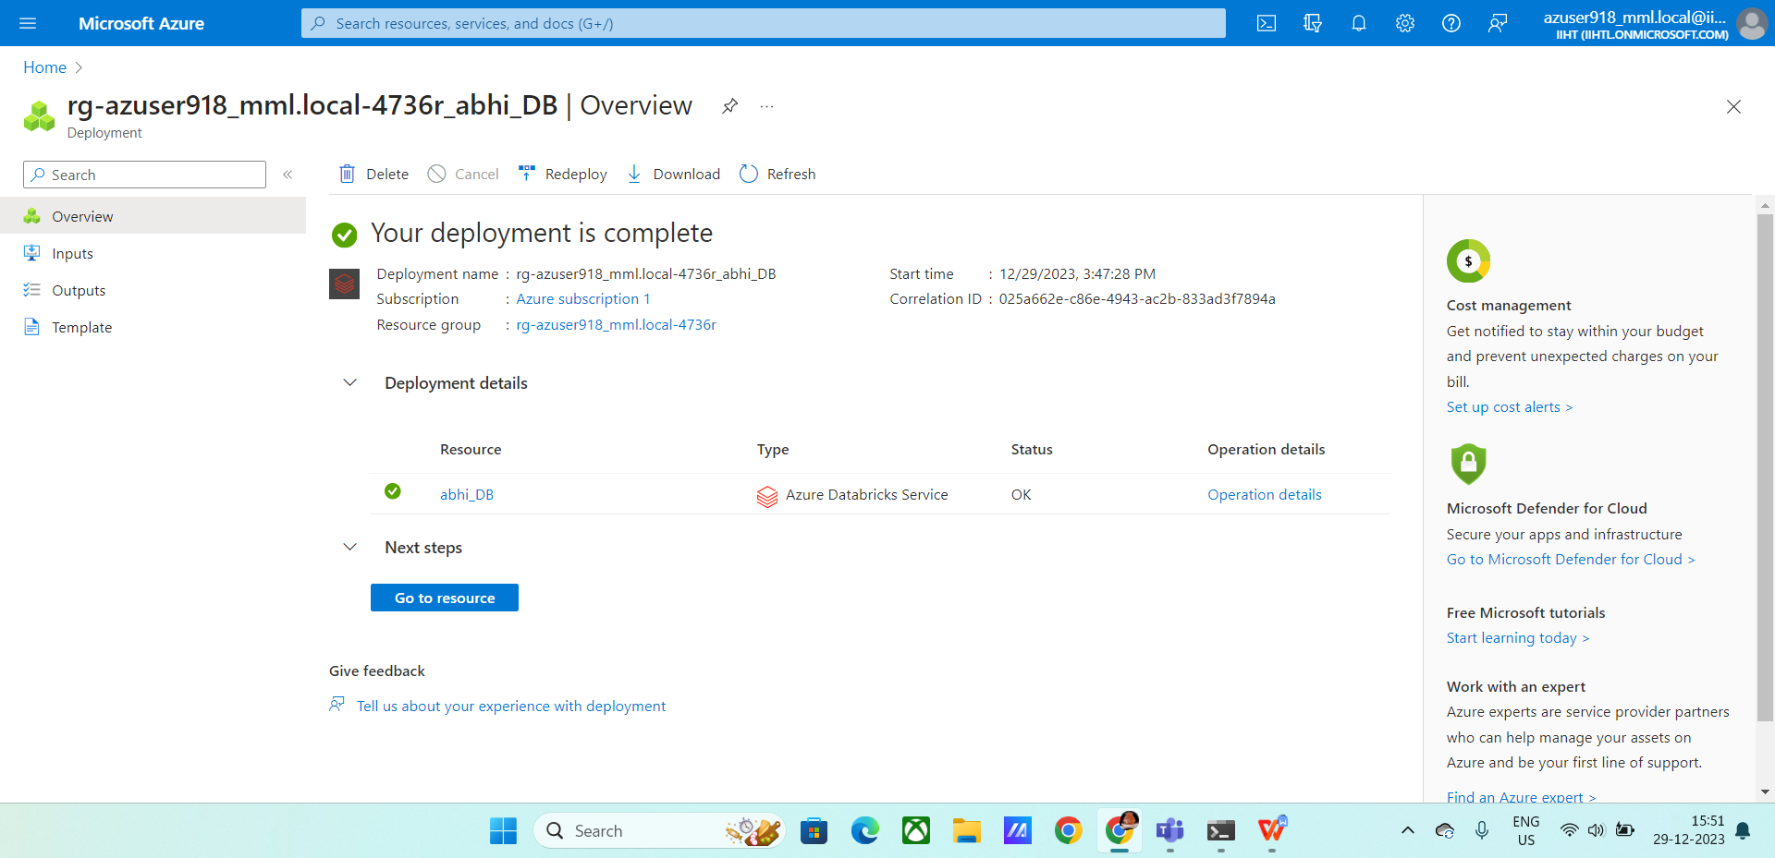

* Click on launch

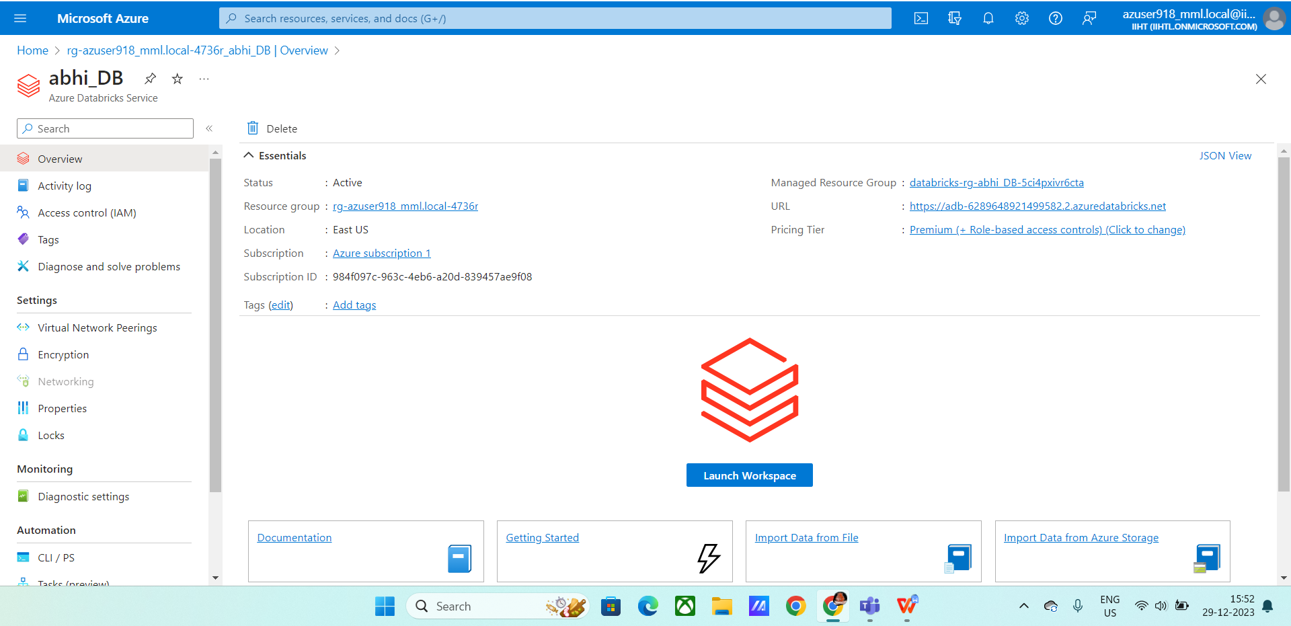

* After launching the Azure databricks, we will get this dashboard

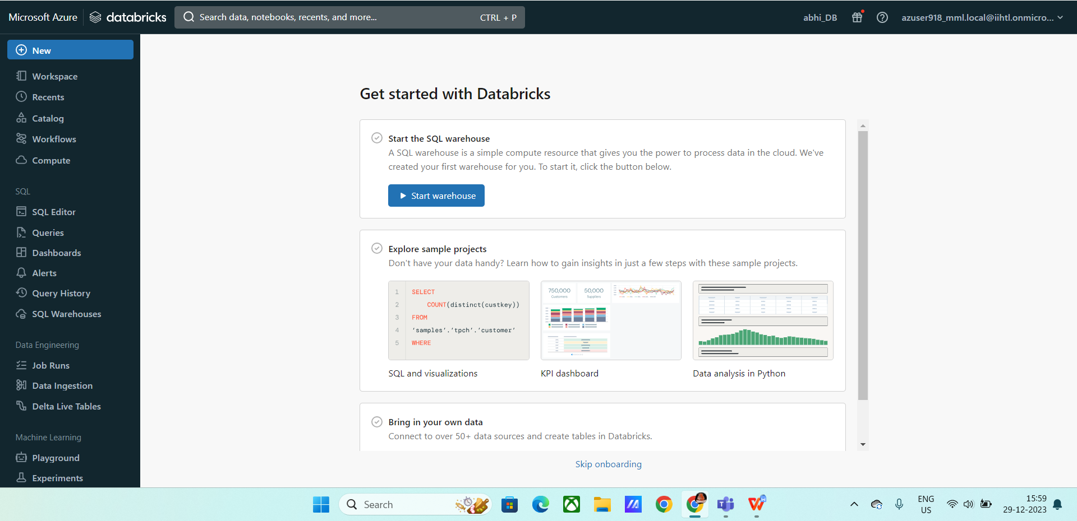

* Click on new.
* Click on notebook
* create a cluster

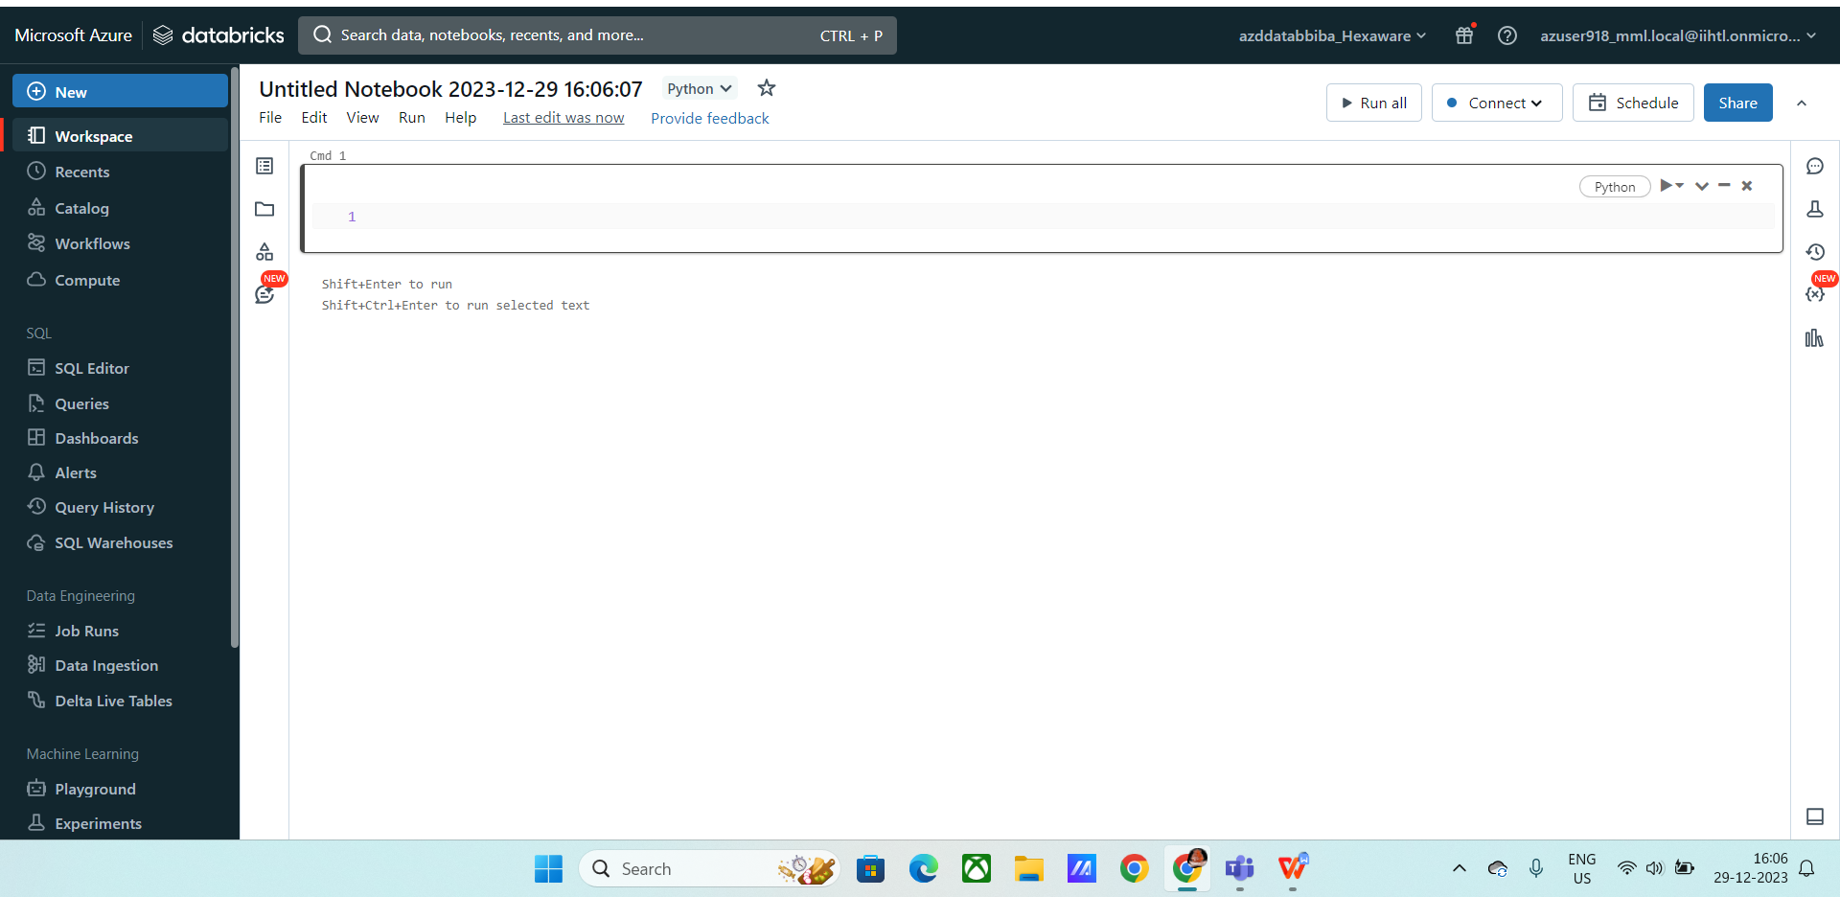

* **Cluster creation**

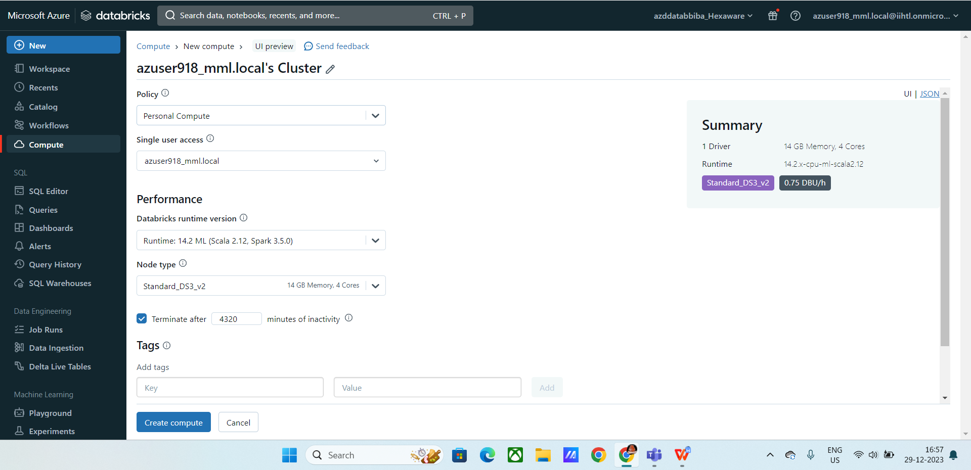

* After creating cluster we started Hands on practice and did the programs.

**Ex1 :**

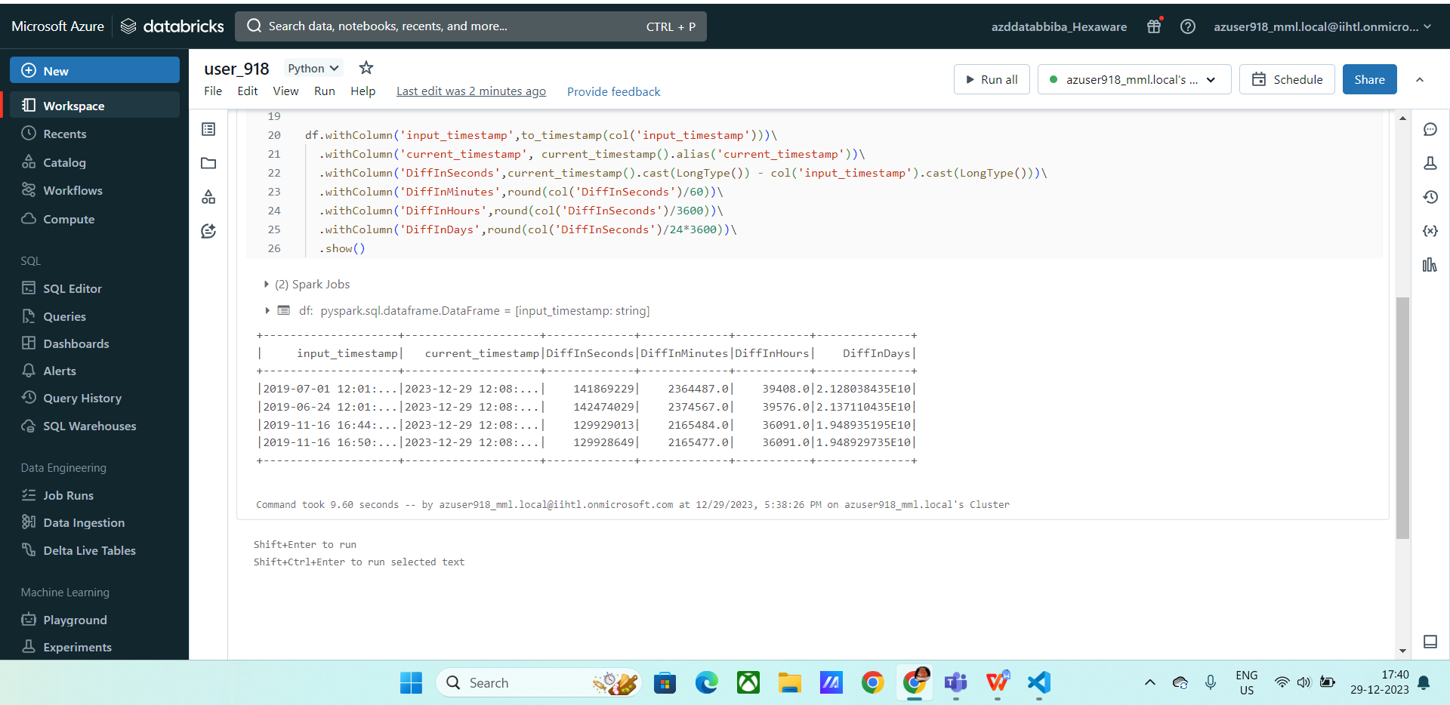

**Ex 2:**

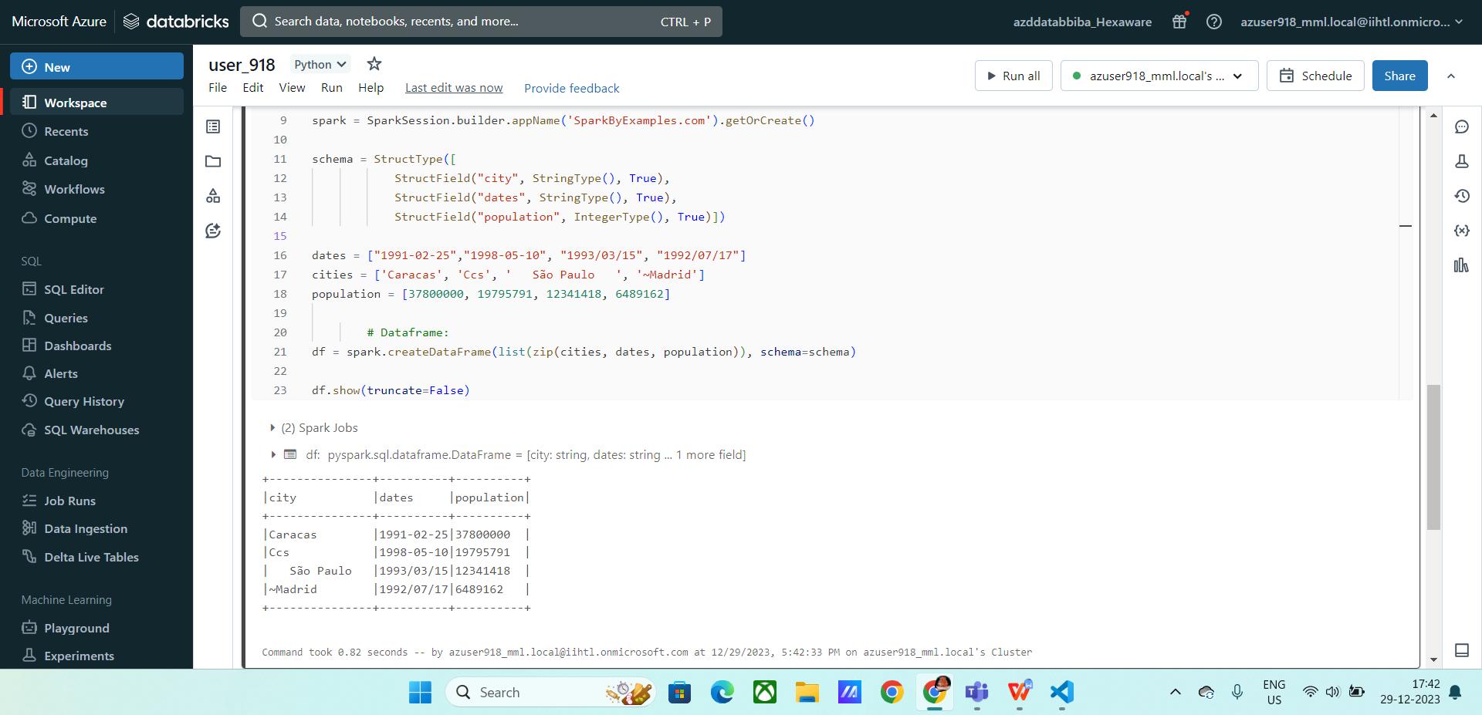

**Ex3 :**

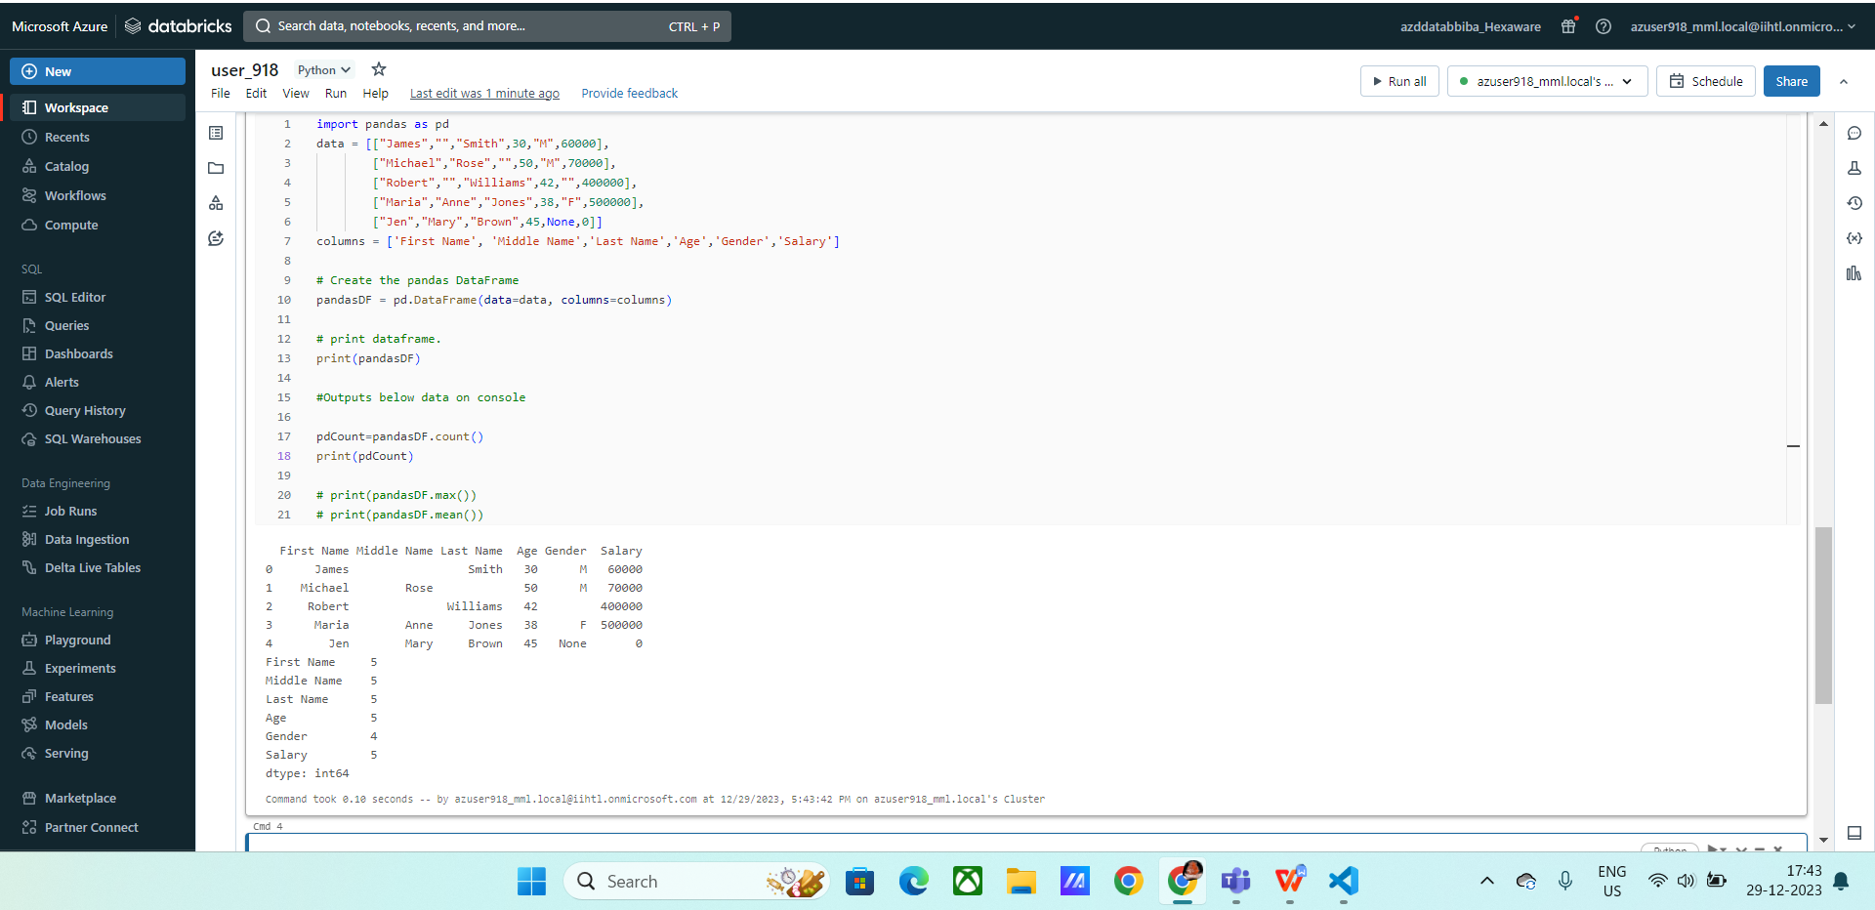

**Ex 4:**

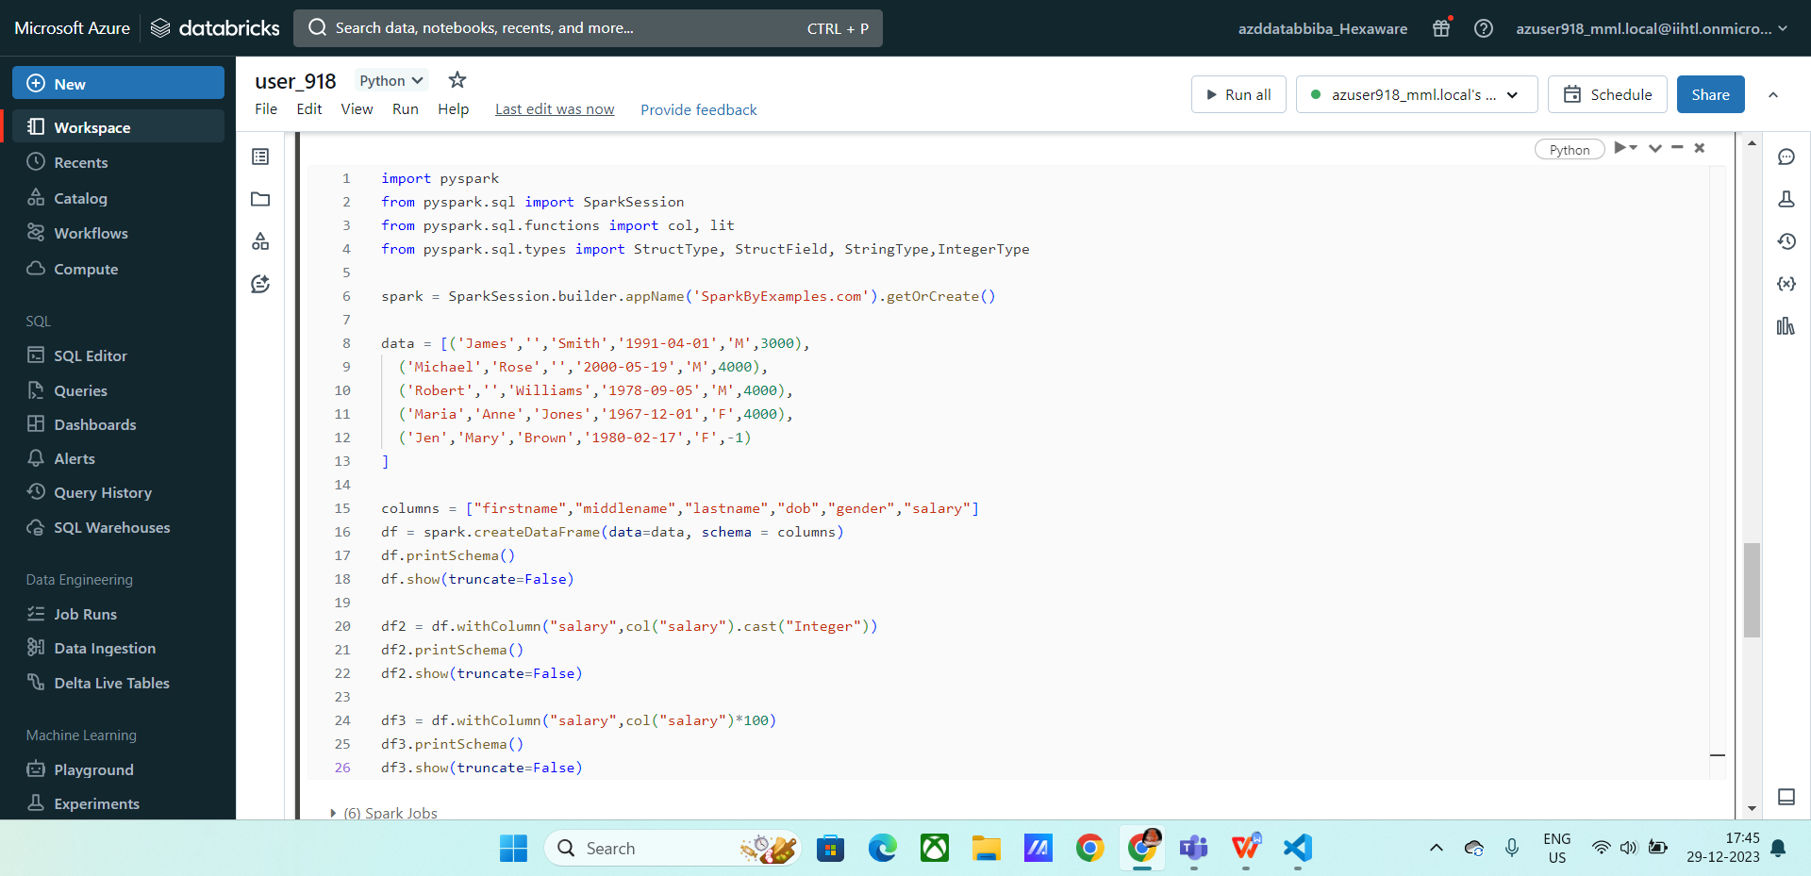

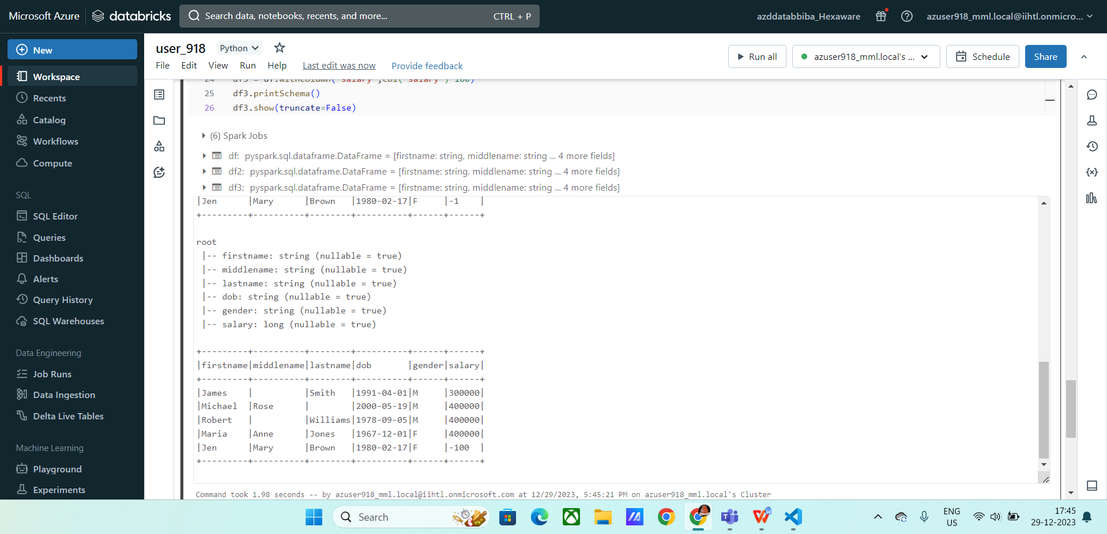

**Ex 5 :**

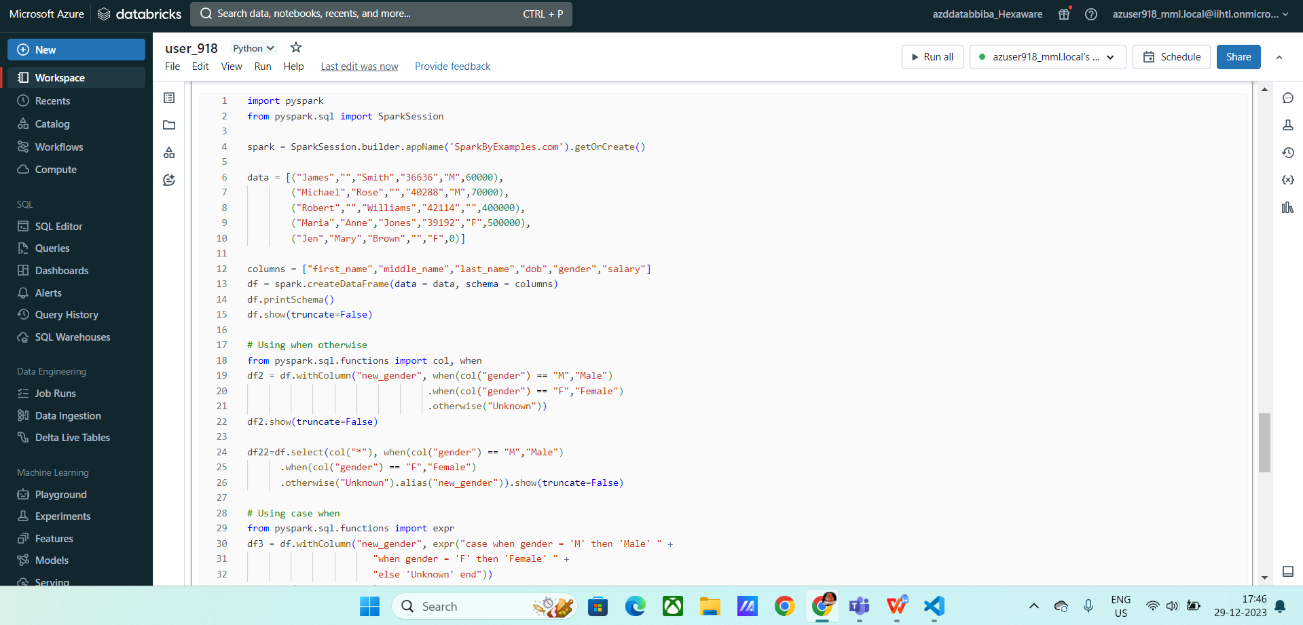

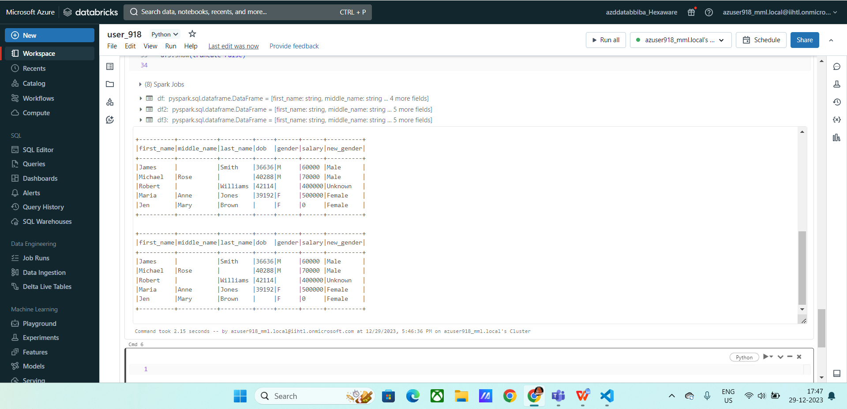

**Ex: 6 :**

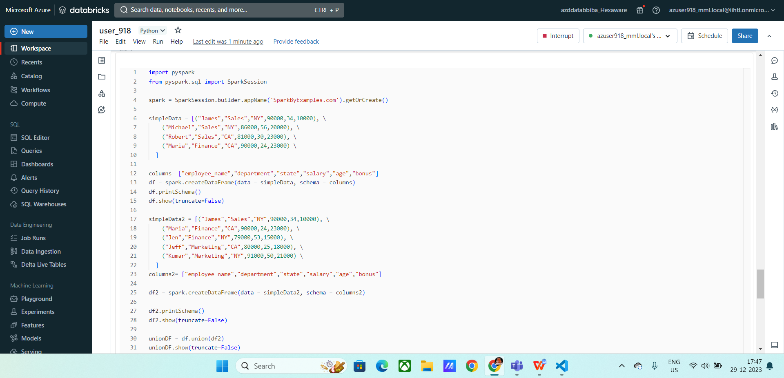

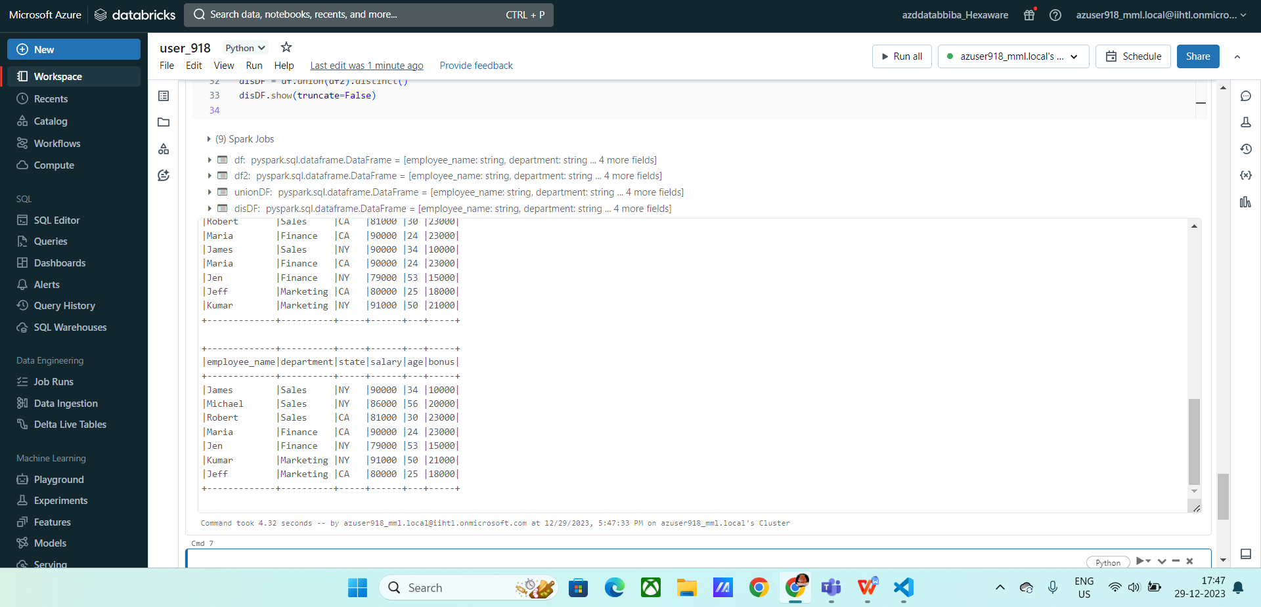

**Ex: 7 :**

